**ARDUINO COMPONENT TESTER**

**INTRODUCTION:**

A component is the lowest unit of any application. So, Component testing is a technique of testing the lowest or the smallest unit of any application. In this method, the testing is performed on each individual component separately without integrating with other component. Basically, a multimeter is used to test the working and values of the component. This project is a minimization and Arduino based component tester. The main objective of this project is to identify the component and its value and also to find if it’s in working condition or broken.

**COMPONENT TESTER:**

In each system, every module receives an input, does some processing and generates the output. The output is then validated against the expected feature. If the system fails to produce the output due to inadvertent use of component or damage in component, the component is tested to find whether it is working or not and to find its value. Using this, the part of error in the system can be determined and corrected. In this project, we make a tester which tests many basic components like Resistors, Capacitors, Inductors, Diode, and every type of transistors (BJTs, MOSFETs, IGBTs, etc.) and many other components.

**WORKING:**

The basic working of this project is, the components are placed in a socket which is connected to an Arduino board where the components working and values are determined and the result is send as a signal to an LCD display. Arduino NANO is the microcontroller used in this project. It sends an input signal to the component which is placed in the socket, every component does its processing with the input signal and generates the output. The output signal produced by these components again sent back to the Arduino board where it gets processed and determine the type of component and its value. After determining the value, it sends the information to be displayed in the LCD screen where we can see and find the components specification. If the component which is inserted in the socket is broken or not working, the output will not be produced by the component, if the microcontroller gets no output signal, that means the component is either broken or not working. And sends this information to the LCD to display that the component is broken. Using this project, the user can easily find which part of the system has error or damage and can change the component to make the system work.

**CIRCUIT DIAGRAM:**

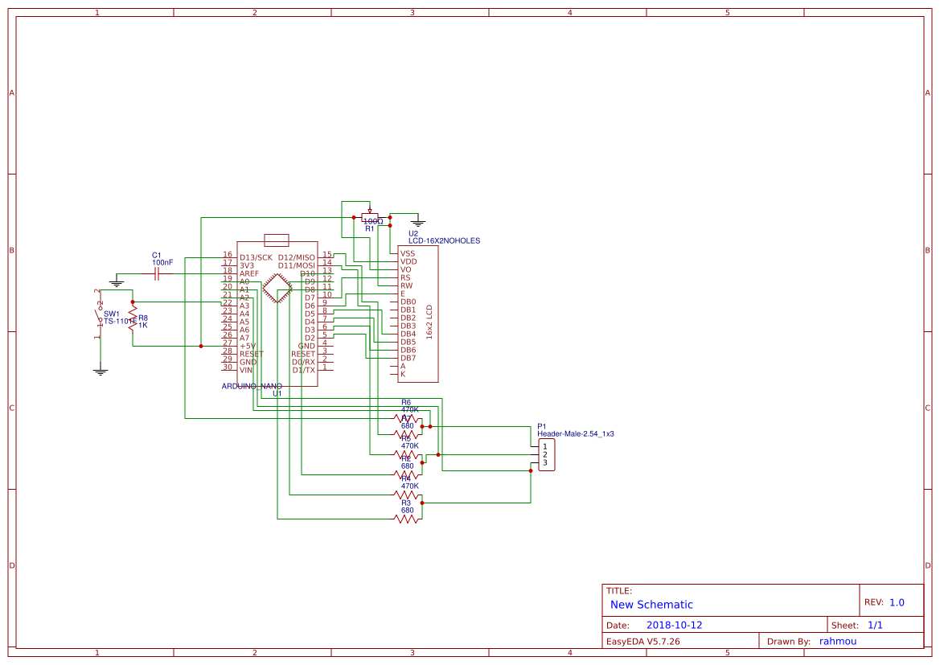

**PROJECT IMAGES:**

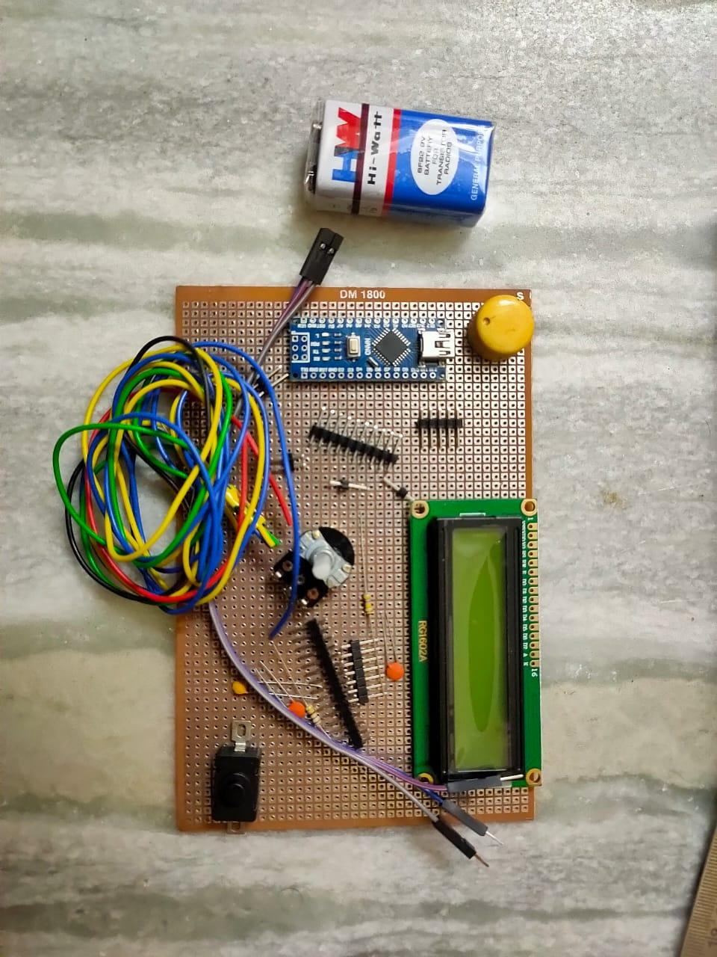

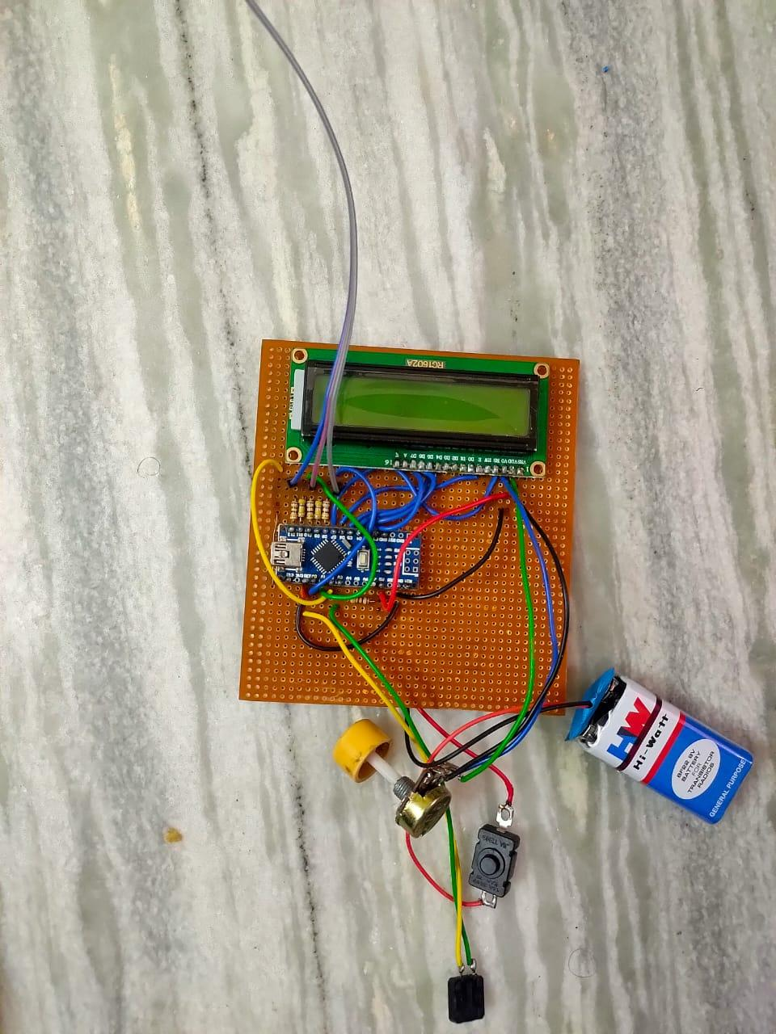

**RESULT:**

This project not only determines if the component is working or not, it also finds the type of component and its values. This can be used to find the part in which the error occurs or damaged part. This device can be used in troubleshooting purposes in many circuits.